

**Journal of Medicinal Plants and By-products (2020) 1: 101-111**

**Original Article**

**Marketing Strategies and Export of Iranian Medicinal Plants**

**Mohammad Hossein Karim1*, Alireza Karbasi2 and Seyed Hossein Mohammadzadeh2**

*1Department of Resource Economics, Kharazmi University, Tehran, Iran*

*2Department of Agricultural Economics, Ferdowsi University of Mashhad, Mashhad, Iran*

Article History: Received: 26 November 2019/Accepted in revised form: 02 May 2020 © 2012 Iranian Society of Medicinal Plants. All rights reserved.

**Abstract**

In order to reduce dependence of Iranian economy on crude oil exports and shift to a multipurpose export economy, export policy orientations should be changed to the benefit of exporting non-oil goods, including agricultural exports. Share of the agricultural sector in non-oil exports to Iran shows that this trend is declining. Therefore, attention should be paid to the expansion of this sector's exports. Statistics and time series of the past years shows that despite Iran's good rank in the production and cultivation level of medicinal plants, the export status of these products is not in a good position. Among the agricultural products, medicinal plants are one of the most important agricultural export items in Iran which play a great role in creating added value for the agricultural sector. The purpose of this study is to investigate the role of marketing strategies on export of Iranian medicinal plants. Necessary data were collected from 30 herbal exporting companies for 2011 – 2017, using simple random sampling. Due to the combined nature of the data collected and the export impact of its amount in previous years, the dynamic panel model was chosen as the superior model. On the other hand, this study attempts to identify the strengths, weaknesses, threats and opportunities for export of medicinal plants. The results showed that differentiation strategies, market development and product development have positive and significant impact on export performance of exporting companies. Market penetration strategy, although not statistically significant, also varies with the export value of medicinal plants.

**Keywords:** Medicinal Plants, Agricultural export, Dynamic panel model

**Introduction**

one of the major problems in developing countries is their excessive reliance on one or a limited number of goods. Recent years of experience have shown that the economy's reliance on crude oil revenue has led to volatility in export earnings. The drop in world oil prices in recent years has created a number of problems for the Iranian economy. Therefore, in order to reduce the dependence of the Iranian economy on crude oil exports and the shift to a multipurpose export economy, export policy orientations should be changed to the benefit of exporting non-oil goods, including agricultural

exports. This will not happen unless opportunities are identified in the export of the agricultural sector and operational zed. The importance of non-oil exports to our country is not covered by any cash. Exports of agricultural products play a major role in non-oil exports and exports are more stable than other sectors [1,2].

Exports of agricultural products accounted for the bulk of non-oil exports [3]. A look at Iran's export statistics shows that during the period 1947-1960, exports of this sector have always increased and increased from about $ 63 million in 1340 to more than 3 million. Billion dollars increased in 2003. In other words, it grew 9.1 percent annually. This figure

Corresponding author: Department of Resource Economics, Kharazmi University, Tehran, Iran

Email Address: karim@khu.ac.ir

|  |  |
| --- | --- |
| **Journal of Medicinal Plants and By-products (2020) 1: 101-111** | **102** |

was 10.5% for the whole Iranian economy [4-6]. In other words, despite the increase in the price of oil and its products during the mentioned period, which mainly constitute the export of the Iranian economy, the agricultural sector has grown almost in line with total exports. During the period 1340-88, about 40% of non-oil exports were allocated to agriculture. In 2015, the total export weight of agricultural sector was 3 million 39 thousand dollars worth 3 billion 390 million 260 thousand dollars which has a share of 6.07 percent of the total weight of export of non-oil goods and 15.86 percent of the total value of export of non-oil goods [7]. As the chart below shows, the share of agricultural exports from non-oil exports accounted for a high percentage during the years 1971-82, but this trend has gradually declined since 2003. The drought of recent years and the lack of appropriate policies have made non-oil exports,

especially agricultural products, particularly disruptive. The share of agricultural exports in non-oil exports in 2015 was 16%, which is 3% lower than in 2014. The share of agricultural exports from non-oil exports in 2018 was 13.5% [8].

As statistics show, the share of agricultural exports to total non-oil exports has been declining in recent years. Iran's export sector has not been well developed due to the lack of an efficient and effective marketing and trading system. So, in most cases, our export goods and services, despite being of good quality and even above world standards, have not achieved their proper status in the global markets due

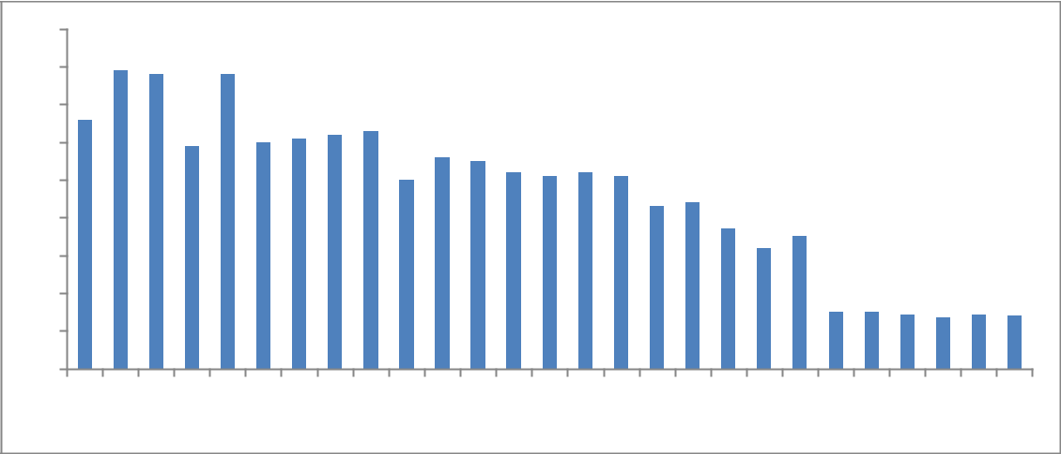

to the lack of a proper foreign exchange information and information system. This raises the need to pay more attention to the proper process of marketing agricultural products for export. The competitiveness of world markets on the one hand and the relative advantage of agricultural products on the other hand make it clearer the need to consider appropriate marketing strategies for export development and to increase the export share of agricultural products from non-oil exports. Adopting appropriate marketing strategies to improve agricultural exports is critical to boosting Iran's foreign trade in non-oil products. The results of research on marketing strategies indicate that export organizations and companies are gradually finding that with proper use of marketing strategies they will achieve lasting competitive advantage in the international arena [9]. Among crops, medicinal plants are one of the most important non-oil export items of Iran, which plays an important role in the development and expansion of non-oil exports.

Marketing strategies are divided into four groups: market penetration strategy, market and product development strategy, and differentiation strategy. Each of these strategies is used based on the exporter's goal.

Each of these four types of strategies is based on the percentage of risk in the market. Market penetration strategy is to enter markets that the company has not yet entered.

|  |  |  |  |  |  |  |  |  |  |  |  |  |  |  |  |  |  |  |  |  |  |  |  |  |  |  |  |
| --- | --- | --- | --- | --- | --- | --- | --- | --- | --- | --- | --- | --- | --- | --- | --- | --- | --- | --- | --- | --- | --- | --- | --- | --- | --- | --- | --- |
| 90 |  |  |  |  |  |  |  |  |  |  |  |  |  |  |  |  |  |  |  |  |  |  |  |  |  |  |  |
| 80 |  |  |  |  |  |  |  |  |  |  |  |  |  |  |  |  |  |  |  |  |  |  |  |  |  |  |  |
| 70 |  |  |  |  |  |  |  |  |  |  |  |  |  |  |  |  |  |  |  |  |  |  |  |  |  |  |  |
| 60 |  |  |  |  |  |  |  |  |  |  |  |  |  |  |  |  |  |  |  |  |  |  |  |  |  |  |  |
| 50 |  |  |  |  |  |  |  |  |  |  |  |  |  |  |  |  |  |  |  |  |  |  |  |  |  |  |  |
| 40 |  |  |  |  |  |  |  |  |  |  |  |  |  |  |  |  |  |  |  |  |  |  |  |  |  |  |  |
| 30 |  |  |  |  |  |  |  |  |  |  |  |  |  |  |  |  |  |  |  |  |  |  |  |  |  |  |  |
| 20 |  |  |  |  |  |  |  |  |  |  |  |  |  |  |  |  |  |  |  |  |  |  |  |  |  |  |  |
| 10 |  |  |  |  |  |  |  |  |  |  |  |  |  |  |  |  |  |  |  |  |  |  |  |  |  |  |  |
| 0 |  |  |  |  |  |  |  |  |  |  |  |  |  | 2006 |  |  | 2009 |  |  | 2012 |  |  | 2015 |  |  | 2018 |  |
| 1992 | 1993 | 1994 | 1995 | 1996 | 1997 | 1998 | 1999 | 2000 | 2001 | 2002 | 2003 | 2004 | 2005 | 2007 | 2008 | 2010 | 2011 | 2013 | 2014 | 2016 | 2017 |  |

**Fig. 1** Agricultural Exports Share of Iranian Non-Oil Exports

**103**

Product and market development strategy are two types of strategies that the company uses to expand sales. Influence strategy is a type of strategy that a company uses to enter markets where it has not been active before [10,11].

Indicators are used to quantify marketing strategies and examine their impact on exports. Market penetration strategy using the number of exported goods sold or exported, the market development strategy with the number of markets (countries) export target, the product development strategy with the number of new brands introduced and the differentiation strategy with the number of packages Commodity or variety in commodity packaging (design, size and color) can be quantified.

The total volume of export of medicinal herbs in the world in 2010 was 2.2 million tons, which in 2016 was about 3.7 million tons. During the same period, the total value of the world's medicinal plants exports increased from $ 12 billion to more than $ 17 billion, representing an average annual growth of 9 percent. [12,13]. The value of imported herbs worldwide in 2016 is over $ 18 billion. As the figures below show, although the volume of medicinal plant exports has been declining and fluctuating for some years, the value of exports has been almost upward, indicating the profitability of the medicinal plant trade globally. China, India, America, Germany and Italy are the largest countries in the world trade of medicinal plants. China, the US, Japan and Germany were the world's largest importer of medicinal plants, respectively, and China, India, Germany and the United States were the largest exporters of medicinal herbs in 2016, respectively.

The figure below shows the top 10 exporting countries for medicinal herbs as well as Iran and the 10 major importing countries for medicinal herbs during the period 2016-2010. It should be noted that despite being the fifth largest producer of medicinal plants in the world, Iran is the 17th largest exporter of these products.

Production and export of medicinal herbs are indicative of the realization of the resistance economy and endogenous export production relying on the advantages of the country. Due to the production and export capacities of the medicinal plants can lead the country in the path of realization of the goals of the

**Karim *et al*.**

resistance economy. The following chart shows the export status of Iran in the production and export of medicinal plants.

**Table1** Weight of global export and import of medicinalplants

|  |  |  |  |  |
| --- | --- | --- | --- | --- |
|  |  | World | Export | Global Import |
|  | year | Amount | (Million | Amount |
|  |  | Tons) |  | (Million Tons) |
|  |  |  |  |  |
|  | 2010 | 2.2 |  | 2.1 |
|  | 2011 | 3.7 |  | 3.2 |
|  | 2012 | 3.6 |  | 3.2 |
|  | 2013 | 3.8 |  | 3.3 |
|  | 2014 | 3.9 |  | 3.4 |
|  | 2015 | 3.6 |  | 3.6 |
|  | 2016 | 3.7 |  | 3.2 |
|  |  |  |  |  |

Source: Economic Trade site

**Table 2** The value of global export and import of medicinalplants

|  |  |  |  |  |
| --- | --- | --- | --- | --- |
|  |  | WorldExport | Global | Import |
|  | year | Amount (billion | Amount | (billion |
|  |  | dollars) | dollars) |  |
|  |  |  |  |  |
|  | 2010 | 12.9 | 13 |  |
|  | 2011 | 17.1 | 16.8 |  |
|  | 2012 | 21.2 | 19.1 |  |
|  | 2013 | 19.1 | 18.2 |  |
|  | 2014 | 19.6 | 18.8 |  |
|  | 2015 | 17.8 | 17.9 |  |
|  | 2016 | 17.4 | 18 |  |
|  |  |  |  |  |

Source: Economic Trade site

In the field of medicinal herbs export to Middle East countries, the first to third ranks to the UAE, Turkey and Saudi Arabia and the last to Iran. This shows that Iran is among the Middle East countries in terms of trade in medicinal herbs. Production is not favorable. n the world, France, Germany, America, Spain, England, Singapore, Netherlands, Belgium and Poland are among the top 10 exporting countries in the medicinal plants industry. This industry has no global exports.

Iran's share of the world market for medicinal plants is very small. The value of Iran's medicinal herbs trade was $ 450 million in 2017, which is $ 35 billion for the entire world economy. The following table shows Iran's valuable share of the world market for medicinal plants.

|  |  |
| --- | --- |
| **Journal of Medicinal Plants and By-products (2020) 1: 101-111** | **104** |

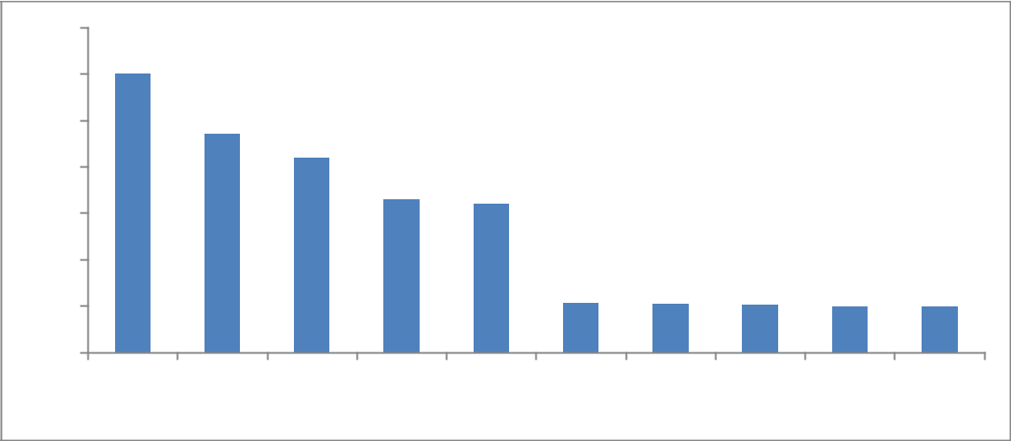

3500

3000

2500

2000

1500

1000

500

0

China USA India Germany Italy japan Taiwan Vietnam France South Korea

**Fig. 3** The Most Important Medicinal Plants Countries in the World in 2016 (Billion Dollars)

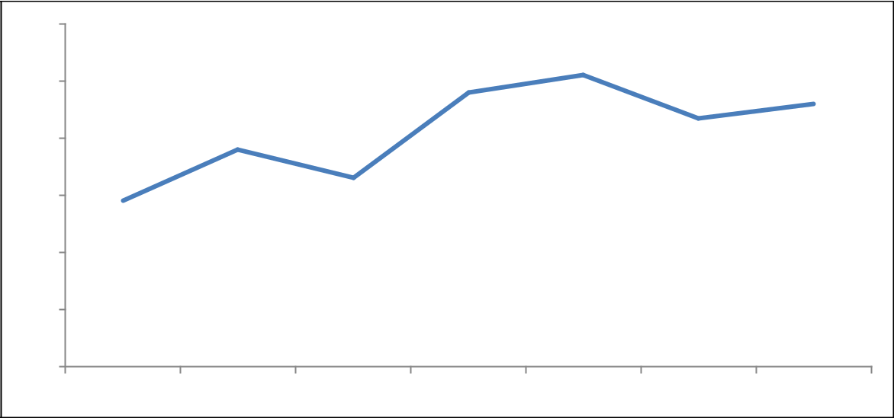

|  |  |  |  |  |  |  |
| --- | --- | --- | --- | --- | --- | --- |
| 600 |  |  |  |  |  |  |
| 500 |  |  |  |  |  |  |
| 400 |  |  |  |  |  |  |
| 300 |  |  |  |  |  |  |
| 200 |  |  |  |  |  |  |
| 100 |  |  |  |  |  |  |
| 0 |  |  |  |  |  |  |
| 2011 | 2012 | 2013 | 2014 | 2015 | 2016 | 2017 |

**Fig. 4** Export of Iranian Medicinal Plants in the Past Years (Million USD)

**Table 3** The share of Iran from medicinal herbs market (Million USD)

|  |  |  |  |
| --- | --- | --- | --- |
| year | Trade value of Iran | Global trade value | The share of Iran (%) |
|  |  |  |  |
| 2015 | 470 | 35700 | 1.3 |
| 2016 | 450 | 35000 | 1.2 |
| 2017 | 480 | 41500 | 1.1 |
|  |  |  |  |

Source: Economic Trade site

The following table shows the top 10 export markets of Iranian medicinal herbs in 2016. Various studies [14,16] show that export target markets of Iranian medicinal plants are not properly selected.

In a study, Lund *et al* [17] examined the export status of medicinal plants in Japan and India. The results of

their study during 2015-2016 showed that Japan and India, with the adoption of bilateral policies and government support for active companies, could hold more than 50% of the market by the end of 2030.

**105**

**Table 4** Iran export target markets in 2016

|  |  |  |  |  |
| --- | --- | --- | --- | --- |
| Rank | Country | Export | Share of Iranian |  |
| amount | Exports (%) |  |
|  |  |  |
|  |  |  |  |  |
| 1 | Turkey | 990 | 41 |  |
| 2 | Pakistan | 473 | 20 |  |
| 3 | Iraq | 203 | 8.6 |  |
| 4 | Germany | 176 | 7.4 |  |
| 5 | Emirates | 153 | 6.5 |  |
| 6 | Spain | 124 | 5.2 |  |
| 7 | Russia | 107 | 4.5 |  |
| 8 | India | 77 | 3.2 |  |
| 9 | France | 26 | 1.1 |  |
| 10 | Italy | 13 | 0.5 |  |
|  |  |  |  |  |

Source: Economic Trade site

The results also showed that tariff fluctuations were one of the important factors in the decline of export growth in some periods. In their study, Tehrani and Razini [18] examined the relative advantage of producing, exporting, and identifying cumin target markets. They showed that Iran has a comparative advantage in cumin exports and that the best target markets for this product were selected by the countries of Sri Lanka, New Zealand, America and Mexico. In a study, Karim *et al* [19] examined the market structure and prioritization of target markets for export of selected Iranian medicinal plants. The results showed that as the numerical value of the Herfindahl index fluctuates from one to four during the period under study, the target market structure during the period under review is closed by two types of dominant and multilateral firms and Iran is diversified in export. Not enjoyable. Also, Pakistan, Saudi Arabia, UAE and Qatar have been Iran's largest trading partners, accounting for between 4% and 22% of Iran's exports. Karim *et al* [20] investigated the impact of export marketing mix strategy on food companies' export performance using a SWOT model. The results showed that food business executives were unaware of the needs of customers and other competitor products' characteristics, or lacked knowledge and knowledge of international marketing, and overall lack of design and implementation of an appropriate export marketing mix strategy suited to export markets. One of the problems of companies is the high quality and quantity of exported food. Karim *et al* [21] evaluated and analyzed the strategies of entering food products into foreign markets. Potential Partners Behavior, International Experience, Technical Knowledge,

**Karim *et al*.**

Marketing Skill, Total Investment, Intensity of Industry Competition, Nature of Activity, and Place Attraction are effective factors in choosing foreign market entry strategies [22]. Investigate the sensitivity of the market and export strategy and its impact on improving corporate export performance they paid. The results showed that export firms have a higher sensitivity and thus a better marketing strategy for export. And as a result, they have had higher export performance over the past three years.

In a study Karim *et al* [23] examined the impact of vertical and horizontal alignment of export strategies on the export of one hundred top companies in Iran. The findings showed that there is a strong positive correlation between alignment and export variables, and secondly, the effect of vertical alignment variable on exports is higher. Karim *et al* [24] examined the relationship between export markets' orientation on export performance of 142 manufacturing companies. The results of the analysis using structural equations indicate a direct relationship between export market trends and export performance. Bahador *et al* [25] studied the effect of macroeconomic variables on saffron exports in a study. The results showed that factors such as the real exchange rate, domestic production, and relative prices affect Iran's saffron exports.

In this study, the role of marketing strategies on the export of medicinal plants has been investigated

and also states the strengths, weaknesses, opportunities and threats of exporting Iranian medicinal plants.

**Material and Methods**

The necessary data were collected from exporting companies for the period 2017-2010 to investigate the role of marketing strategies on medicinal plant exports. Since the information on medicinal plant exporting companies has been collected for several years, so the econometric model used is the panel model. On the other hand, considering the impact of export value of medicinal plants on its value in previous years, it seems necessary to use a dynamic model. Therefore, in this study, a dynamic panel model was used to investigate the role of marketing strategies on medicinal plant export. The statistical population of this research is total of herbal exporting companies in Khorasan Razavi. According to the

|  |  |
| --- | --- |
| **Journal of Medicinal Plants and By-products (2020) 1: 101-111** | **106** |

statistics, there are 85 herbal exporters in Khorasan Razavi province. Due to the small size and statistical population of the sampling method, the census was selected. Due to the nature of the questionnaire questions, some companies were not surveyed due to lack of information or unwillingness to respond in the sample. Thirty questionnaires were selected after deletion of confused items to investigate the purpose of the study. The questionnaires were completed in 2017 based on 8-year data and statistics of exporting companies during the period of 2010-2017and in-person referral to foreign sales experts. Therefore, the sample size of data was 240 to test the hypotheses. Cronbach's alpha coefficient and Spss22 software were used to assess the reliability or reliability of the questionnaire. Cronbach's alpha coefficient for the whole questionnaire was 0.73 and it was in a good level, so the reliability of the questionnaire was acceptable and acceptable.

The use of hybrid data in econometrics has many advantages over the use of cross-sectional or time series data. The combined data takes into account the information of different and dynamic sections at the same time. However, the inclusion of some variables in the model structure leads to inefficiencies in estimating econometric models. Composite data consisting of time series data and cross-sectional data illustrates the effect of these inconsistent or unmeasured variables on cross-sectional data over one year or time series data for a cross-section. . Combined data covers the past trends of variables and provides confidence in dynamically considering variables. In this method, a cross section or a group of individuals are examined. Since this method does not require much time series data and data, it also answers many questions about the behavior of variables, according to the researchers. Most studies have been included. Combined data is referred to as a set of data that is often selected as (N) observations by a large number of randomly selected cross-sectional (T) variables over a given period of time. Mixed data or T × N data. The dynamic panel pattern is as follows. [26-29].

∑

The SWOT technique or matrix is a tool for identifying threats and opportunities in the external environment of a system and recognizing its internal strengths and weaknesses in order to assess the situation and formulate a strategy for guiding and

controlling the system [30, 31]. Analyzing the internal environment (strengths and weaknesses) as well as the external environment (opportunities and threats) is a general tool and a systematic approach to the problem that helps planners and policymakers in decision-making situations [32, 33]. The most important internal and external factors that can influence the future of any activity are strategic factors that are summarized and summarized in SWAT matrix analysis [34-35].

**Result and Discussion**

The table below summarizes the independent variables examined in the study. As can be seen, each of the marketing strategies has been quantified using an appropriate index. Market penetration strategy using the number of exported goods index, market development strategy using the number of export target markets, product development strategy using the number of newly introduced brands, and the differentiation development strategy using the number of quantitative packaging packages has been. Market penetration strategy is a type of strategy that can measure customer loyalty [36]. When a company or organization wants to increase sales or the number of sales of its current products to its current customers, it uses the strategy of penetration in the market. When the company's current customer market is saturated and the market is so large that the company's current share continues to grow and the company's share is relatively small and the company wants to find new customers in newer markets, the market development strategy is useful to take. When the current market is saturated and the company has the ability to produce new products, if the new product is produced and offered to current customers, the product development strategy is used. The differentiation strategy is done when the company wants to produce a new product and market it in a new market, which has a high risk, as well as the costs of research and development and marketing in new markets. Given the nature of the time series of the data collected, the maneuverability of the variables must first be examined in order to perform the data analysis [37]. Before performing the reliability of the variables, a cross-sectional correlation test should be tested in the data. This is

|  |  |  |
| --- | --- | --- |
| **107** | **Karim *et al*.** |  |
|  |  |

because cross-correlation sometimes results in the panel being mistakenly voting. There are several tests for cross-sectional correlation in panel data. The most important is the boys' CD test. The statistic obtained in this test is 7.625 and its significance level is 0.486. Based on this test, the null hypothesis of cross-sectional independence is confirmed. This cross-sectional dependency can be between time and place. The following table shows the results of the reliability test of the variables using the IPS test. Based on the level of explanatory variables estimated. Given the nature of the panel of data being studied, its type must be specified in order to analyze the information. For this purpose, the Hausman test was estimated to determine the effects of fixed or random effects. The Hausman test statistic was 14.15 and the significance level was 0.0031. Therefore, the fixed effects model was chosen as the superior model.

The following table shows the results of the dynamic panel model to examine the role of marketing strategies on medicinal herb exports. The market penetration strategy, which shows the number of sales of various herbs and products, although not statistically significant, has a positive effect on the export value of the herbs exporting companies. The types of export items of corporate herbs increase over time, increasing the export value of these products. Although this coefficient is not statistically significant, its correlation with the dependent variable indicates its impact on the export status of the company.

The next variable is the market development strategy or the number of export target countries that companies sell to medicinal plants. The coefficient of this important variable is positive and significant.

This means that by increasing this variable, by increasing the number of export drawer target

**Table 5** Some Independent variable

product of medicinal plants (UAE, Spain, Afghanistan, Germany, etc.) export rate is significantly increased. The product development strategy includes new mechanisms and measures that companies take every year to improve the status of their foreign trade. The strategy is for medicinal plants to come in different qualities and prices, to distribute the product more widely in the markets, to be organic and to create new brands. Theoretically, the increase in the quantity of these measures will increase the export and improve the foreign trade situation of the companies. The coefficient of this variable is positive and significant in the estimation model.

Thus, with the increase of one unit (each of the measures mentioned) the export volume of the company will increase by 1.22 units. This increase is also statistically significant at 5% level. Given the greater coefficient of this variable than other strategies, this strategy can be considered as an important strategy to increase corporate exports.

The most recent variable affecting export value is the adoption of a differentiation strategy. In this strategy, the company's activities focus on providing a unique product or service. The coefficient of this variable is positive and statistically significant.

This reflects the fact that with the increasing number of product packages of medicinal herbs or new marketing methods internationally, the export rate is significantly increased. So that by increasing each unit of this variable (one unit increase in product packaging per year for each company or acquiring a new marketing method) the export increases by 0.13 units.

|  |  |  |  |  |  |  |  |  |  |  |
| --- | --- | --- | --- | --- | --- | --- | --- | --- | --- | --- |
|  | Variable |  | Unit of measurement |  | Mean |  | Min |  | Max |  |
|  |  |  |  |  |  |  |  |  |  |  |
|  | Company history |  | Year | 15.85 | | 4 | | 100 | |  |
|  | Corporate capital |  | Million USD | 42 | | 14 | | 80 | |  |
|  | Risk |  | Likert spectrum | 3.4 | | 1 | | 5 | |  |
|  | Marketing costs Market |  | Million USD | 11.28 | | 5 | | 15 | |  |
|  | penetration strategy Market |  | Number of exported goods | 3.38 | | 1 | | 5 | |  |
|  | Development Strategy Product |  | Number of export markets | 4.1 | | 1 | | 10 | |  |
|  | Development Strategy |  | Number of new brands | 4.14 | | 2 | | 10 | |  |
|  | Differentiation strategy |  | Variety in packaging | 11.21 | | 3 | | 20 | |  |
|  |  |  |  |  |  |  |  |  |  |  |

Source: Research Finding

**Journal of Medicinal Plants and By-products (2020) 1: 101-111**

**Table 6** IPS Test

|  |  |  |  |
| --- | --- | --- | --- |
|  | Variable | Test Statistic | Sig |
|  |  |  |  |
|  | Company history | -3.54 | 0.08 |
|  | Corporate capital | -2.81 | 0.01 |
|  | Risk | -4.41 | 0.00 |
|  | Marketing costs Market | -1.99 | 0.01 |
|  | penetration strategy Market | -3.81 | 0.03 |
|  | Development Strategy Product | -2.77 | 0.04 |
|  | Development Strategy | -2.08 | 0.02 |
|  | Differentiation strategy | -3.12 | 0.005 |
|  | Export value | -3.17 | 0.004 |
|  |  |  |  |

Source: Research Finding

An increase in the number and types of packaging as an indicator of this strategy has led to increased sales and a slight increase in the export of medicinal herbs, and ultimately to increased exports. The export interruption variable has a significant and positive effect on exports. This indicates that the increase in the export of medicinal plants is dependent on the amount of medicinal plants in the past year, in addition to being affected by various variables. Other influencing variables are also reported in Table 6. These variables include company experience, sales manager education, company risk, and company marketing and capital costs.

Based on the results of the SWAT matrix, export improvement strategies of Iranian medicinal plants can be expressed. Export strategies for medicinal plants include 4 offensive strategies, competitive strategy, defensive strategy and conservative strategy. These strategies are based on assessing the strengths, weaknesses, threats and assumptions facing the export of medicinal plants.

A: Competitive strategies

1. Enjoying the relatively high economic value of medicinal plant products in export markets to overcome the production, trade and processing of medicinal plants in competing countries. [38-39].
2. Taking advantage of comparative advantage in production to counter the emergence of new competitors
3. Using knowledgeable specialists in the latest practices of herbal processing to counteract the low

**108**

level of innovation and knowledge as a determinant of competitive advantage

B: Offensive strategies

1. Extend applied research to improve production quality with the knowledge of production and processing experts
2. Support the establishment of marketing and export management companies with the knowledge of experts in desirable processing practices
3. Use of appropriate geographical location and access to markets, relying on the relative advantage of medicinal plants.
4. Improving political and economic relations with other countries by developing trade relations with other countries and international trade organizations
5. More government attention to the export of medicinal plants due to the high demand elasticity of global demand

C: Defensive strategies

1. Coordination and communication between public and private sectors to strengthen policy making

1. Observance of global standards of processing and packaging of medicinal plants to compete with competitors in order to prevent crop sales
2. Improving the resolution of political problems with some of the countries trading and strengthening the foreign diplomacy of the government
3. Launch a banking facilitation system for currency transfers to reduce the impact of political and economic sanctions

**Table7** Estimation of Dynamic Panel Model

|  |  |  |  |  |
| --- | --- | --- | --- | --- |
| Variable | Coefficient | Z | Sig |  |
| Test |  |
|  |  |  |  |
| Company history | 0.13 | 2.88 | 0.007 |  |
| Corporate capital | 0.35 | 0.96 | 0.41 |  |
| Risk | 0.26 | 5.21 | 0.00 |  |
| Marketing costs Market | 0.38 | 2.33 | 0.037 |  |
| penetration strategy Market | 1.44 | 0.82 | 0.34 |  |
| Development Strategy Product | 0.39 | 2.48 | 0.003 |  |
| Development Strategy | 1.49 | 2.37 | 0.028 |  |
| Differentiation strategy | 0.13 | 3.44 | 0.001 |  |
| Export value | 1.11 | 2.77 | 0.05 |  |

Source: Research Finding

**109**

D: Conservative strategies

1. Extending applied research to improve the quality of production due to traditional herbal processing and non-compliance with appropriate export standards
2. Active participation in international fairs to

introduce herbal brands in target markets

1. Increased attention of the government to the export of medicinal plants and their expansion due to the lack and weakness of production and export trade unions.
2. Using an educated and specialized workforce to improve the marketing and marketing of medicinal plants
3. Develop political and economic relations with other countries due to political problems with some of the trading parties

Conclusion and Recommendations

In this study, the role of marketing strategies on the export of herbal exporting companies was investigated. For this purpose, after collecting and completing the required information from 30 exporting companies for the period 2010-2017, statistical analysis of the variables affecting the export was carried out. After making sure that the panel data were manually and performing the necessary tests to estimate the best model of the dynamic composite data model was estimated. The results show the positive impact of marketing strategies on the export of medicinal plants. The

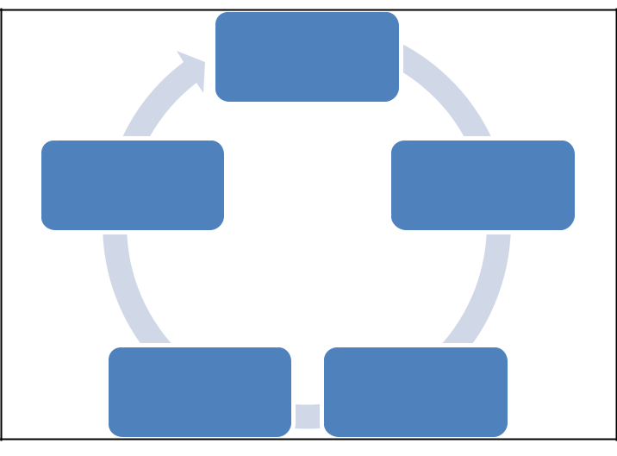

**Karim *et al*.**

following figure outlines the growth pattern of medicinal plants exports in general. Exports require consideration of the four components of sustainability in target markets, adoption of appropriate marketing and non-marketing strategies, prioritization of target markets, and government and private partnerships. These components are closely related. Export development requires simultaneous attention to all four of the following influential factors.

In order to determine the appropriate pattern for the export of medicinal plants, it is necessary to examine the actions that must be taken by both the public and private sectors. In the public sector in both domestic and foreign policy areas and in the private sector in both domestic and foreign productions, export strategies of medicinal plants are examined.

Coordinated communication between the government and the private sector through the Dialogue Council can have constructive interactions for the country's economy relying on the goals of the resilient economy. Delivering part of the power to the private sector for export is another important component that if implemented, Part of the problem for businessmen and exporters will be solved because of the bureaucratic bureaucracy of the government and the parallelism of government bodies. The lack of up-to-date circulars and implementing guidelines for export and import are important issues that concern the private sector for the medicinal herbs trade.

|  |  |
| --- | --- |
| **Export** | |
| Prioritize target | Persistence in |
| markets | target markets |
| Government and | Proper export |
| private sector | strategy |

**Fig. 7** Export pattern of medicinal plants according to research information

|  |  |  |
| --- | --- | --- |
| **Journal of Medicinal Plants and By-products (2020) 1: 101-111** | **110** |  |
|  |  |

Laws and regulations that need to be developed over time due to changes in the laws of the country of trade, change of capacity of factories and change of type of contracts. Inexperienced exporters entering the foreign export market are among the issues that sometimes place the trust of the trader on the Iranian goods.

And the Iranian businessman needs to use the capacities of the public and the private sector to create the necessary conditions for the sector to participate and act in economic decision-making and action.

The product development strategy also had the highest coefficient. Given that the product development strategy is more effective than other strategies (given the significant coefficient obtained), it is recommended that exporting herbs companies develop and improve their exports, depending on the circumstances. Considering the different qualities of medicinal plants, the different prices in different packaging and the sale of organic medicinal plants are the components of access and implementation of this strategy. Corporate Exports It is imperative to identify new markets and countries in order to export. Therefore, it is recommended that companies help improve the export status of medicinal plants by expanding their R&D units to identify more markets. In the short and long run, this would make a big profit for these companies. The market has hurt companies in the long run. Coordination before adopting appropriate marketing strategies cans double the benefit of all exporting companies, herbal manufacturers, and improving Iran's position in the global marketplace.

**References**

1. Karim Koshteh MH. Extracting the contingency curve of fuel cost-pollution the issue of environmental economic burden distribution. J Advanced Res in Law & Econ. 2017; 8:2454-2463.
2. Karim Koshteh MH. Strategic planning for sustainable

tourism development in central Zagros mountains. J Econ & Management Perspectives. 2018;12:39-47.

1. Vilere MP. Effects of export assistance and distributor support on the performance of SMEs: The Case of Portuguese Export Venn- tares. Inter Small Business J. 2008;27:12-29.
2. Karim MH. Global financial crisis impact on gold market in Iran, International j humanities & cultural studies (EBSCO). 2015;2:1020-1028.
3. Karim, M.H. Using Logit model in determining the role of agricultural cooperatives in crop insurance demand in Saravan area (Sistan & Baluchestan), DAV. International J Sci. 2015;4:91-96.
4. Karim, MH, Karim ME, Safdari M, Arabi H (2017) Evaluation of human resources re-engineering and knowledge management processes on the economy of Sirjan free trade zone (Iran). Inter J Business & Econ Aﬀairs (IJBEA). 2017;2:127-134.
5. Majlis Research Center, Expert Report. 2016.
6. World Trade Organization Reports. 2016.
7. Sheyba A, Olkk onen R, Mitr onen L, Kajalo S. Market Sensing Capability and business performance of retail entrepreneurs”. Contemporary Management Res j.

2014;4:219-236.

1. Karim Koshteh MH. Greening the desert "agro-economic impact of India Gandhi of Rajasthan”; Renaissance

Publication, New Delhi-India.1995.

1. Karim MH, Danesh Jafari D, Hashemi Z. Resistive economy and rural-urban migration (Iran and Indian Experience), overall growth & development, New Delhi-India. 2017.
2. Ministry of Agriculture Jihad. Surface cultivation and production of garden products. Agricultural Statistics. 2016.
3. Ministry of Agriculture Jihad. Agricultural statistics, planning and support deputy. 2016.
4. Mohammadzadeh H, karbasi A, Mohammadi H. Factors affecting the choice of strategies for entering the foreign market of medicinal plants. J Agric Econ & Develop.

2019;32:112-142.

1. Musteen M, Datta D, Herrmann P. Ownership structure and CEO compensation: Implications for the choice of foreign market entry modes. J International Business Studies. 2009;40:321-338.
2. Najafi A, Karbasi A, Mohammadzadeh H. Investigating the factors affecting the import of vegetable seeds to Iran and selected countries. J Agric Econ and Development. 2019;33:78-91.
3. Lund S, Walsh P. SWOT and AHP hybrid model for sport marketing outsourcing using a case of intercollegiate sport. Sport Management Review. 2008;14:361-369.
4. Tehrani E, Razini A. Investigating and analyzing diversity in the export markets of Iran in different provinces. J Business Studies. 2017;11:187-209.
5. Karim MH, Valitabar Y, Memarian H. Emission and

environmental goals in decision making modeling for load dispatch. Pollution. 2020;6:591-501.

1. Karim MH, Hosseini SB, Farooq A, Arabi H, Takroosta A. A strategic review on economic dispatch distribution and environmental considerations. Restaurant Business. 2019;118:166-176.

|  |  |  |
| --- | --- | --- |
| **111** | **Karim *et al*.** |  |
|  |  |

1. Karim MH, Sardar Sharaki A. The Economic Evaluation of Efficiency of Pomegranate Growers in Khash City, Iran. Econ. 2018;23:191-207.
2. Hunger J, Wheelmen TL. Essentials of Strategic Management. 2th Edition. Upper Saddle River N. J.: Prentice-Hall. 2015.
3. Karim MH. Prediction of Iran’s GDP by Using

Autoregressive Moving Average Model, ACTA Scientific Agriculture. 2019;1:158-162.

1. Karim MH, Hosseini SB, Farooq A, Kochekzade S, Delfan M. A Study on Causal Relationship Between Sugar Beet Supply and Sugar Price - Sustainability Issues and Opportunities, GIS Business. 2019;14:445-462.
2. Bahador A, Mosavi SH, Khalilian S. The effect of macroeconomic variables on saffron exports. Agric Economy. 2018;13:27-45
3. Tsang E. Influences on foreign ownership level and entry mode choice in Vietnam. Inter Business Review. 2005;14:441-463.
4. Kushwaha G. Agrawal S. Effect of export experience and market scope strategy on export performance in India. Inter Business Rev J. 2015;22:80-95.
5. Wilkinson M, Nguyen N. A Contingency Model of Export Entry Mode performance. Australasian Marketing J. 2003;4:11-38.
6. Wu W, Lee YT, Tseng ML, Chiang YH. Data Mining for

Exploring Hidden Patterns Between and Its Performance. Knowledge Based Systems. 2010;23:397-401.

1. Anselin L, Le Gallo J, Jayet H. Spatial Panel Econometrics, in the Econometrics of Panel Data, Edithed by Laslo Matyas and Patrick Semester, Springer. 2005.
2. Anselin L. Geode 0.9 User’s Guide. Spatial Analysis

Laboratory (SAL). Department of Agricultural and

Consumer Economics, University of Illinois, Urbana-Champaign, IL. 2006.

1. Lee H, Yang T, Chen Ch, Chen Y. A fuzzy hierarchy integral analytic expert decision process in evaluating

foreign investment entry mode selection for

Taiwanese bio-tech firms, Expert Systems with Applications J. 2011;38:3304-3322.

1. Li T. Reviving traditions in research on international market entry. Advances Inter Marketing. 2003;14:1-8.
2. Karim Mh. Determination of technical efficiency by parametric method in pomegranate gardens at sistan region-

Iran. Inter J Agronomy & Plant Production. 2013;4:1672-1678.

1. Karim MH, Shahraki G, Hashemi A. Pricing water in the irrigation network of Sistan province. Inter J Agric & Crop Sci. 2012;4:1039-1044.
2. Madsen T. Successful export marketing management: some empirical evidence, Inter Marketing Rreview J. 2005;44:41-57.
3. Kohansal M, Dehghani M, Rashidi F, Esfaniari S. Investigating the export status of medicinal plants with a comparative advantage approach, the structure of the world

market and Iran's trade plan. Agric Economics. 2019;13:133-160.

1. Karim MH. Agricultural water reforms versus climate changes. Basic Res J Agric Sci Review. 2014;3:06-12
2. Karim M. H. Socio-economic role of agricultural cooperatives in S&B province. Inter J Farming & Allied Sci. 2013;2:704-711.